Third Sunday of Advent – Year C  Reading I: Zephaniah 3:14-18a  Responsorial Psalm: Isaiah 12:2-3, 4, 5-6  Reading II: Philippians 4:4-7  Gospel: Luke 3:10-18  Readings may be found on the US Bishop’s website:  https://bible.usccb.org/bible/readings/121221.cfm#main-content | 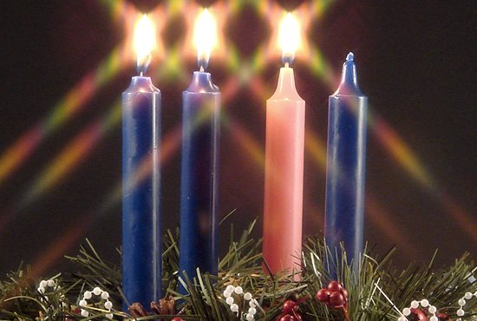
The Third Sunday of Advent is called Gaudete Sunday. It is based on the first word in the second reading, Rejoice. It marks the halfway point in the Advent season (when we have the long fourth week of Advent.) During this third week, the rose or pink candle is lit to express the joy and expectation of the coming celebration.

Between the Gospel passage and the one last week, John called the people to repentance and warned that "every tree that does not bear good fruit will be cut down." This leads to the question that begins our passage. "What should we do?" He calls people to justice and honesty. It is important to note that John is not addressing religious leaders but the outcasts of society, tax collectors, soldiers, and the common people. They are called to act justly, not cheat, and to share what they have so that all might have what is needed.

John also makes a clear distinction between his ministry and the one coming after him. John calls people to a repentance that will prepare them for the promised one. That promised one will have a far greater impact than what John has. The baptism that he will offer is one of Spirit and fire. Spirit is the source of life. God breathed into the first person, and he became a living being. The Spirit of God is the source of all life, and the gift of the Spirit will bring new life. In the conversation with Nicodemus, Jesus says that one must be born again through water and the Spirit. Fire is associated with cleansing and purification. This new baptism will cleanse and purify all who receive it. This will allow them to receive the new life of the Spirit.

This is the only time in the three-year cycle of readings that the Prophet Zephaniah is read on Sunday. He ministered about 630 before Christ. Most of his message is gloomy and threatening. He warned the people that the day of the Lord was coming and that it would be one of suffering. The passage that we read today is addressed to those who survived the cleansing and is a message of hope and expectancy. Once the cleansing is over, the favor of God will be seen. There is no reason to fear, for God is in your midst. As the Christian community, we know that God is with us and that fear has no place for love drives out fear.

Paul writes to the Philippians from prison for preaching Christ. He is suffering, and there is cause for anxiety. He tells them that these current challenges should not be the focus because God is near. When we hand over these cares to God, there will be peace that is beyond our understanding, for it will be the work of God. Interestingly, Paul encourages them to be thankful before they receive the answer to their prayers as a sign of trust in God's providence. The hallmarks of the Christian life should be rejoicing (for God is near, in our midst) and charity (support and encouragement of one another).

Key themes
Fruits of the Spirit – Joy and Peace
Justice and Catholic Social Teaching
Moral conversion
The work of the Holy Spirit in the lives of believers

Reflection questions:
What would John say to you if you asked, “What must I do?”
What response of you have when you think about Christ being near you? Do you rejoice, have fear, or something else?
How are you aware of God's presence in your life, manifest it, or symbolize it?
In what areas of your life do you need God to present or near you?
Have you experienced the peace of God that is beyond all understanding?

Prayer suggestions:
For the church: that we may surrender our anxieties to God and rejoice knowing that God is always with us

For conversion of heart: that the fire of the Spirit will cleanse us of greed, selfishness, narrowness of mind, and hardness of heart so that we may be people of the light

For a flowering of justice: that we may strive to fulfill our duties to others and use our gifts to ease the suffering and promote the wellbeing of all our brothers and sisters

For all who feel overwhelmed by life: that God’s message of "have no fear" may renew their hearts and fill their spirits with hope

© Joseph Milner, 2021

